Order Of Service

Singing: Psalm 51b—CW page 87

Reading: Psalm 128

Opening Hymn: TLH 341

Reading: James 1:1-11

Request Hymn: CW Supplement 752

Reading: Luke 18:9 -14

Sermon Hymn: TLH 656

Sermon Text: Song Of Solomon 1:11

The Crown

Prayer

The Apostles’ Creed, TLH page 12

Holy Communion

The Lord's Prayer

The Blessing

Closing Hymn: TLH 644

* * * * * * * * * * *

Bible Study: Lambs: John 13:1-5, 15; Serving One Another
Sheep: Proverbs 4:10-19; Your Choice
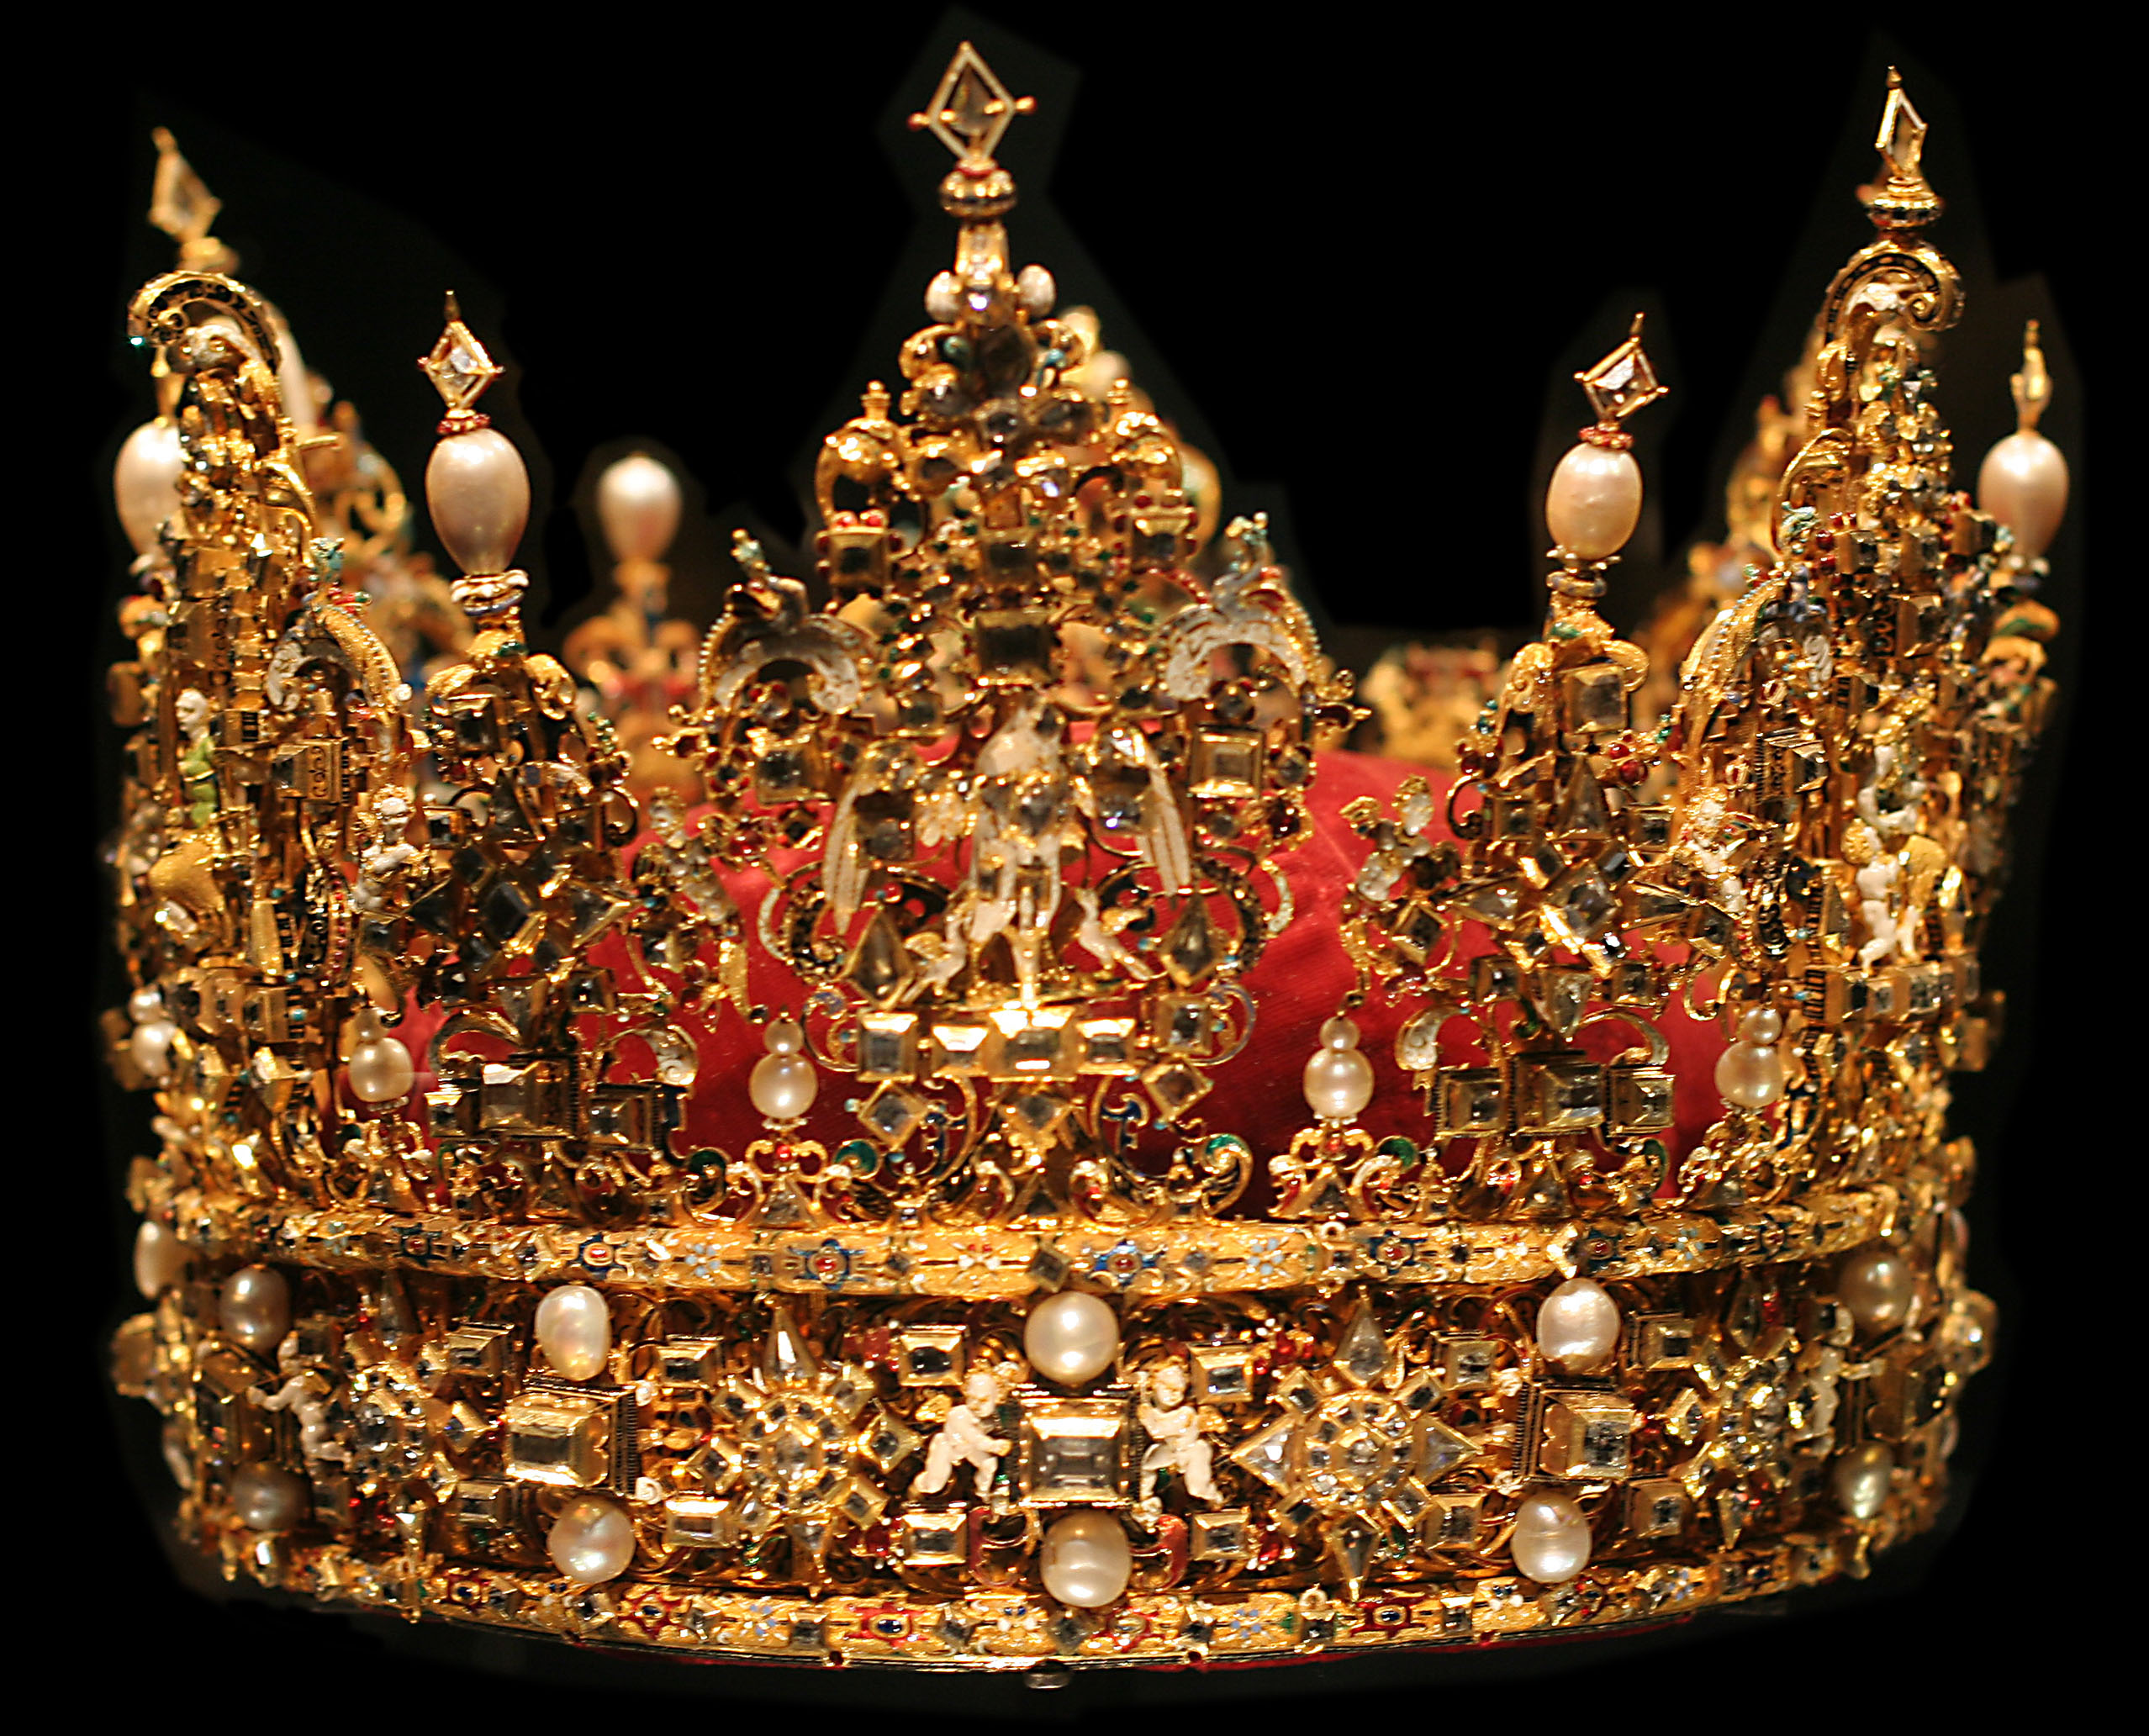

The Crown

Water
Of
Life

23 August 2015

W A T E R O F L I F E

Independent Christian Church—Conservative Lutheran Doctrine

Worship Service: 9:30 a.m. Bible Study: 10:45 a.m.

Larry Cooper, Pastor E-Mail address:
111 N. Ridge Road lcooper@wateroflife.cc
Coon Valley, WI 54623 Web Site:
Phone: (608) 452-2105 www.wateroflife.cc

* * * * * * * * * * * * * * * * * * * * * * * * * * *

Sermon Text: Song Of Solomon 1:11

The Crown

* * * * * * * * * * * * * * * * * * * * * * * * * * *

11. We will make thee borders of gold with studs of sliver.

Here in verses 9-11 of chapter 1 of Song of Solomon, the Bridegroom (Jesus Christ) is comparing his Bride (his elect, the Church) to a mighty warrior. Surrounded by powerful enemies, she emerges victorious. We could perhaps summarize these verses with the words of Romans 8:37—“”Nay, in all these things we are more than conquerors through him that loved us.”

This morning we are looking at verse 11, which brings us to the blessed conclusion of our warfare in this great and terrible wilderness. The Bride finds herself standing at the Marriage Altar about to be united with her beloved Bridegroom and enter with him into his eternal Kingdom of Glory.

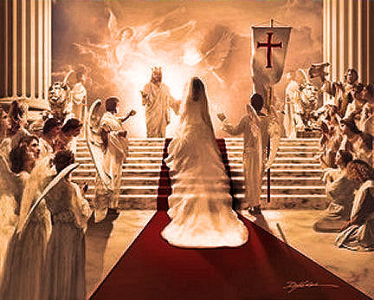

Related Passages:

Genesis 1:26-28
Genesis 2:18-24
Esther 2:12
Esther 2:15
Esther 2:17
James 1:12
Revelation 2:10

